TopBike New System Proposal

William Gerlach, Liam Goldstein, Ethan Amadon, & Todd Armstrong
BSAD 4700 – System Design & Implementation
Dr. Brady Chen
May 16, 2025

Table of Contents
Part 1 - Project Scope and Feasibility 4
Business and System Context Analysis 4
Company Overview 4
Project Overview 4
System Proposal 4
System Feasibility 4
System Request 4
Project Sponsor 5
Business Need 5
Business Requirements 5
Business Value 5
Special Issues or Constraints 5
Feasibility Analysis Report 6
Technical Feasibility 6
Economic Feasibility 6
Operational Feasibility 6
Conclusion 6
Cost-Benefit Analysis 7
Overview 7
ROI and Break-even Point 7
Conclusion 7
Part 2 - Systems Requirements 8
Requirement Definition 8
Functional Requirements 8
Non-Functional Requirements 8
Use Case Analysis 9
Use Case 1 9
Use Case 2 11
Use Case 3 14
Data Flow Diagrams (DFDs) 17
Context Diagram 17
Level 0 Diagram 17
Lower-level Diagrams (Level 1) 18
Part 3 - Data Models 20
Entity-Relationship Diagram 20
Diagram 20
Overview 20
Model Breakdown 21
Entities and Attributes 21
Relationships 21
Primary and Foreign Key Validation 22
Normalization 22
CRUD Matrix Table 23
Part 4 - User Interface Design 24
User Interface 24
User Profiles 24
Interface Structure Diagram 25
UI Prototypes 26
Physical Data Flow Diagrams 29
Structure Chart 30
Part 5 - Test Plan 31
Physical ERD 31
Diagram 31
Test Plans 32
Point-of-Sale (POS) System 32
Online Ordering System 34
Invoice Generation System for Trade Customers 36

Part 1 - Project Scope and Feasibility

Business and System Context Analysis

Company Overview
TopBike is a bicycle shop owned and managed by Herbert, offering a range of products including bicycles, mopeds, accessories, and repair services. The business also fulfills telephone orders for both individual customers and trade clients. Due to increasing competition from large retailers like Malfords, Herbert has secured a £400,000 loan to expand his shop, doubling its floor space. The goal is to increase annual revenue from £800,000 to £1,600,000 within three years. A key component of this expansion is improving the outdated manual information system, which is essential for managing the anticipated increase in sales and inventory.

Project Overview
Herbert has commissioned a £2,000 feasibility study to analyze TopBike's current system and explore modernization options. The existing processes rely heavily on manual record-keeping, leading to inefficiencies in stock management, order processing, and financial tracking. Key issues include inaccurate stock records, delayed invoicing, discount fraud, and limited tracking of outstanding payments, which total approximately £40,000.

System Proposal
To address these challenges, one of TopBike's employees, Ged, has proposed a new IT system, which includes two PCs, barcode scanners, and a web-based ordering platform. The estimated cost is £10,000 for hardware and an additional £5,000 annually for Ged's salary increase. However, Herbert lacks technical expertise to evaluate this solution.

System Feasibility
Our team will conduct a feasibility study to determine whether Ged's system is a viable option or if an alternative, such as a commercial off-the-shelf (COTS) solution or a cloud-based inventory management system, would better suit TopBike's needs. This project aims to develop a logical model of the current system, identify inefficiencies, and propose an improved system that aligns with TopBike's expansion goals while ensuring operational efficiency and financial stability.

System Request

Project Sponsor
Herbert, Owner/Manager of TopBike

Business Need
TopBike is expanding to compete with large retailers. Herbert secured a £400,000 loan, but the manual system is inefficient. A computerized system is needed to improve operations and double turnover in three years.

Business Requirements
- Automate stock control to ensure accurate inventory tracking and prevent stock discrepancies.
- Implement a point-of-sale system to record sales in real-time and integrate with stock updates.
- Digitize customer and trade orders to improve order tracking and reduce processing delays.
- Introduce an online ordering system via a website to expand market reach and increase sales.
- Automate invoice tracking and payment reminders to reduce outstanding debts.
- Implement security controls to prevent unauthorized discounts and potential stock theft

Business Value
- Improves operational efficiency by reducing manual record-keeping.
- Minimizes stock discrepancies, reducing over/under-ordering.
- Speeds up customer transactions with real-time sales recording.
- Increases revenue by allowing online orders.
- Enhances customer satisfaction through better order fulfillment and tracking.
- Reduces outstanding debts by automating payment reminders.

Special Issues or Constraints
- The system must be operational within two months to support business growth.
- Budget of £10,000 for hardware and initial setup.
- Ongoing costs include £5,000 per year for system maintenance and £400 per year for website hosting.
- The feasibility of using Ged’s proposed system versus a professionally developed system should be evaluated.
- System must be user-friendly for non-technical staff.

Feasibility Analysis Report

Technical Feasibility
TopBike’s proposed information system is technically feasible. The company has access to modern computing resources, cloud-based storage, and experienced IT personnel who can implement and maintain the system. The software required for inventory management, customer relations, and order processing is readily available, either as an off-the-shelf solution or through custom development. Integration with existing hardware and online platforms should be straightforward, minimizing technical risks.

Economic Feasibility
The financial viability of the system is strong. While the initial investment in software, hardware, and training will require capital, the long-term benefits outweigh the costs. Improved operational efficiency, reduced manual errors, and enhanced customer service will lead to higher revenue and lower overhead costs. Additionally, potential increases in online sales and improved customer retention further justify the investment. Conducting a cost-benefit analysis confirms that the return on investment (ROI) is favorable.

Operational Feasibility
The system aligns with TopBike’s business objectives and operational needs. Employees will require some training, but the learning curve is manageable. The new system will enhance inventory tracking, streamline customer interactions, and optimize supply chain management, leading to smoother business operations. Moreover, user adoption is expected to be high due to the system’s ease of use and clear benefits in daily tasks.

Conclusion
Based on the technical, economic, and operational feasibility analysis, the proposed information system for TopBike is viable and should proceed to the next phase of development.

Cost-Benefit Analysis

Overview
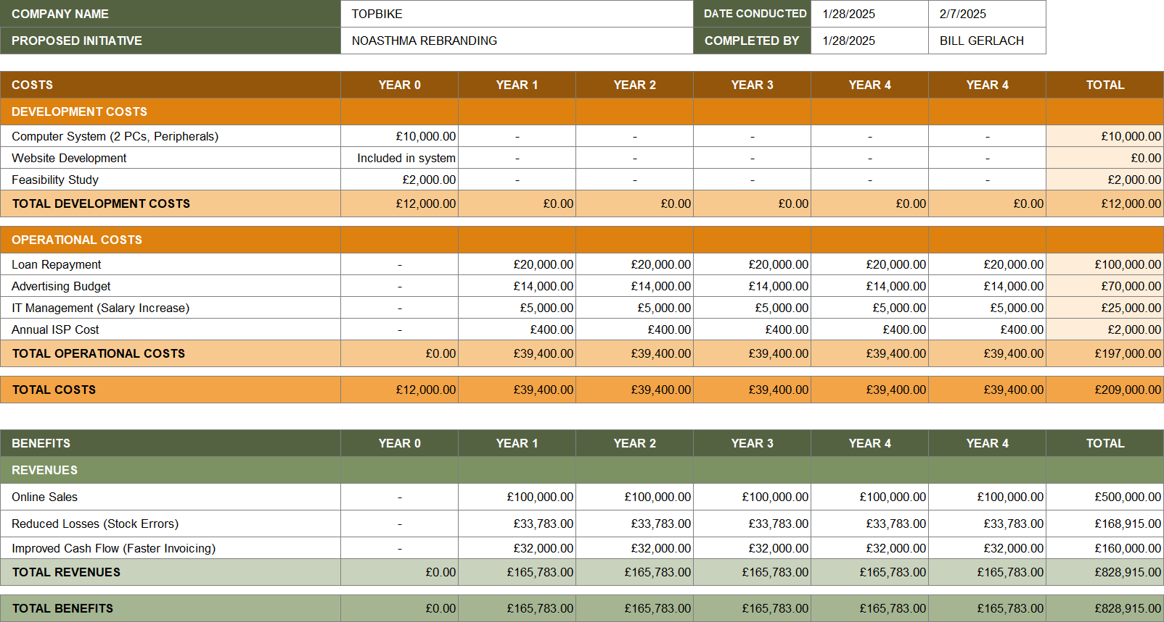

ROI and Break-even Point
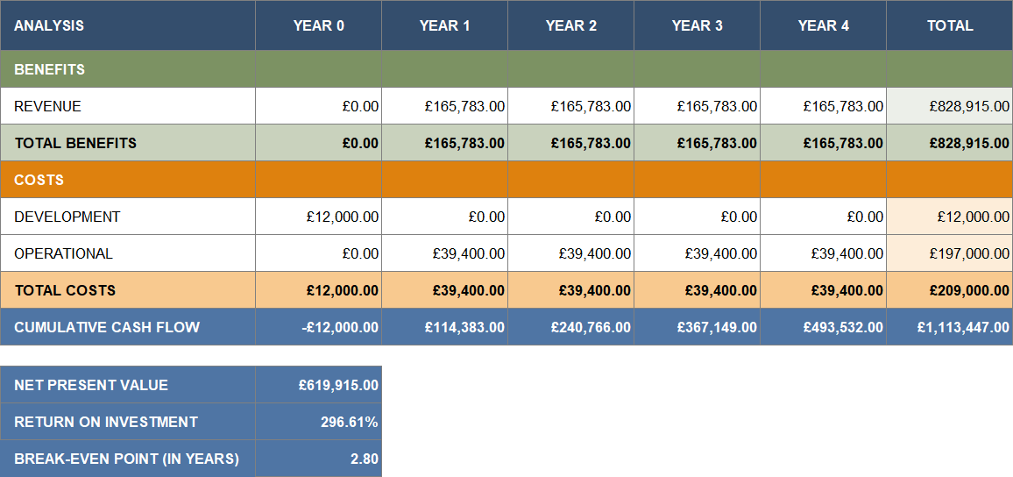

Conclusion
Because of the aggressive rebranding strategy and system improvements that TopBike plans to employ, it is projected that there will be a roughly 300% return on investment. Our team believes that Herbert should move forward with this plan, as the company stands to gain significant cash flow and long-term sustainability.

Part 2 - Systems Requirements

Requirement Definition

Functional Requirements
Stock Management Automation: The system must track inventory levels in real-time. Automatic updates should be made when stock is purchased, sold, or reordered. Low stock alerts must be generated when items reach a predefined threshold.
Point-of-Sale (POS) System: Sales must be recorded in real-time. The system should integrate with inventory updates. It must support multiple payment methods (credit card, cash, online payments).
Customer & Trade Order Processing: Orders must be digitized and tracked from initiation to fulfillment. The system must allow for customer order status tracking. The system should support bulk trade orders with specific discounts.
Online Ordering System: Customers must be able to place orders via the website. The system should provide live stock availability on the website. Order confirmations and updates should be sent via email.
Invoice Tracking & Payment Reminders: Automatic invoice generation for purchases. Payment reminders should be sent for outstanding balances. The system should track overdue payments and flag high-risk customers.
Security & Fraud Prevention: Role-based access control should be implemented to prevent unauthorized actions. Employee discount approvals must be logged and require manager authorization. Activity logs should be maintained for all system transactions.

Non-Functional Requirements
Usability & Accessibility: The system must have an intuitive user interface for non-technical staff. It should support multiple languages for diverse customers. The web interface must be mobile-responsive.
Performance & Scalability: The system should handle at least 500 transactions per hour without performance degradation. It must support at least a 2x increase in concurrent users within three years.
Reliability & Availability: The system should maintain at least 99.9% uptime. Daily backups should be performed to prevent data loss.
Security & Compliance: The system must use encryption for sensitive data. It must comply with GDPR and PCI DSS for payment security.
Maintainability & Support: The system should be modular for easy updates. An admin panel should allow system updates and troubleshooting.

Use Case Analysis

Use Case 1
Use Case Description
Use Case Name: Processing a Customer Purchase | ID: 1 | Importance Level: High
Primary Actor(s): Customer, Cashier
Short Description: This describes how a customer selects products, the cashier processes the transaction, and the system updates inventory and records the sale.
Trigger: Customer initiates a purchase at checkout.
Type: External / Temporal

Major Inputs
Description | Source
Selected product(s) | Customer
Scanned barcode or manual entry | Cashier
Payment method selection | Customer

Major Outputs
Description | Destination
Updated inventory | System
Sales transaction record | System
Printed receipt | Customer

Major Steps Performed
1. Customer selects product(s) for purchase. | 5. System processes payment.
2. Cashier initiates the checkout process. | 6. System prints a receipt.
3. System displays the total price. | 7. System updates inventory and records the transaction.
4. Customer selects and provides a payment method.

Information for Steps
Step Description | Required Data
Product selection | Product list
Checkout initiation | Selected products
Display total price | Product prices
Payment processing | Payment details
Inventory update | Product quantity
Transaction recording | Sales data

Use Case 2
Use Case Description
Use Case Name: Placing an Online Order | ID: 2 | Importance Level: High
Primary Actor(s): Customer, System
Short Description: This describes how a customer selects items online, provides necessary details, and confirms the order, after which the system processes payment and updates stock.
Trigger: Customer initiates an order on the website.
Type: External / Temporal

Major Inputs
Description | Source
Selected items | Customer
Shipping and payment details | Customer
Order confirmation | Customer

Major Outputs
Description | Destination
Stock updated | System
Order confirmation email sent | Customer
Payment processed | System

Major Steps Performed
1. Customer logs into the website. | 4. System verifies stock availability.
2. Customer selects items and adds them to the cart. | 5. Payment is processed securely.
3. Customer proceeds to checkout and provides shipping/payment details. | 6. Order is confirmed and queued for fulfillment.

Information for Steps
Step Description | Required Data
Customer login | User credentials
Item selection and cart addition | Product list
Checkout process | Shipping/payment info
Stock verification | Inventory database
Payment processing | Secure transaction data
Order confirmation | Order details

Use Case 3
Use Case Description
Use Case Name: Generating an Invoice for Trade Customers | ID: 3 | Importance Level: High
Primary Actor(s): Trade Customer, System
Short Description: This describes how an invoice is generated for trade customers after bulk purchases, with applicable discounts and recorded payment terms.
Trigger: Trade customer places a bulk order.
Type: External / Temporal

Major Inputs:
Description | Source
Selected products | Trade Customer
Bulk discount application (if applicable) | System
Payment terms agreement | Trade Customer

Major Outputs
Description | Destination
Invoice generated | Trade Customer
Payment due date recorded | System
Outstanding balance updated | System

Major Steps Performed
1. Trade customer places a bulk order. | 4. Invoice is sent to the trade customer.
2. System calculates total price, applying bulk discounts if applicable. | 5. Payment terms are recorded in the system.
3. System generates an invoice. | 6. System updates outstanding balances.

Information for Steps
Step Description | Required Data
Bulk order placement | Selected products
Price calculation | Product prices, discount policies
Invoice generation | Order details, customer information
Invoice delivery | Customer contact details
Payment terms recording | Agreed payment terms
Outstanding balance update | System financial records

Data Flow Diagrams (DFDs)

Context Diagram

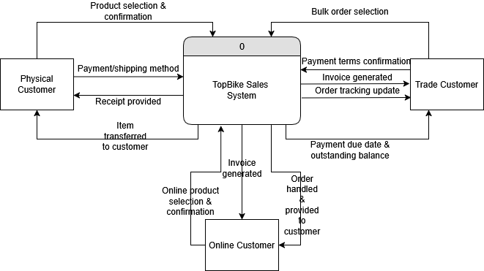

Level 0 Diagram
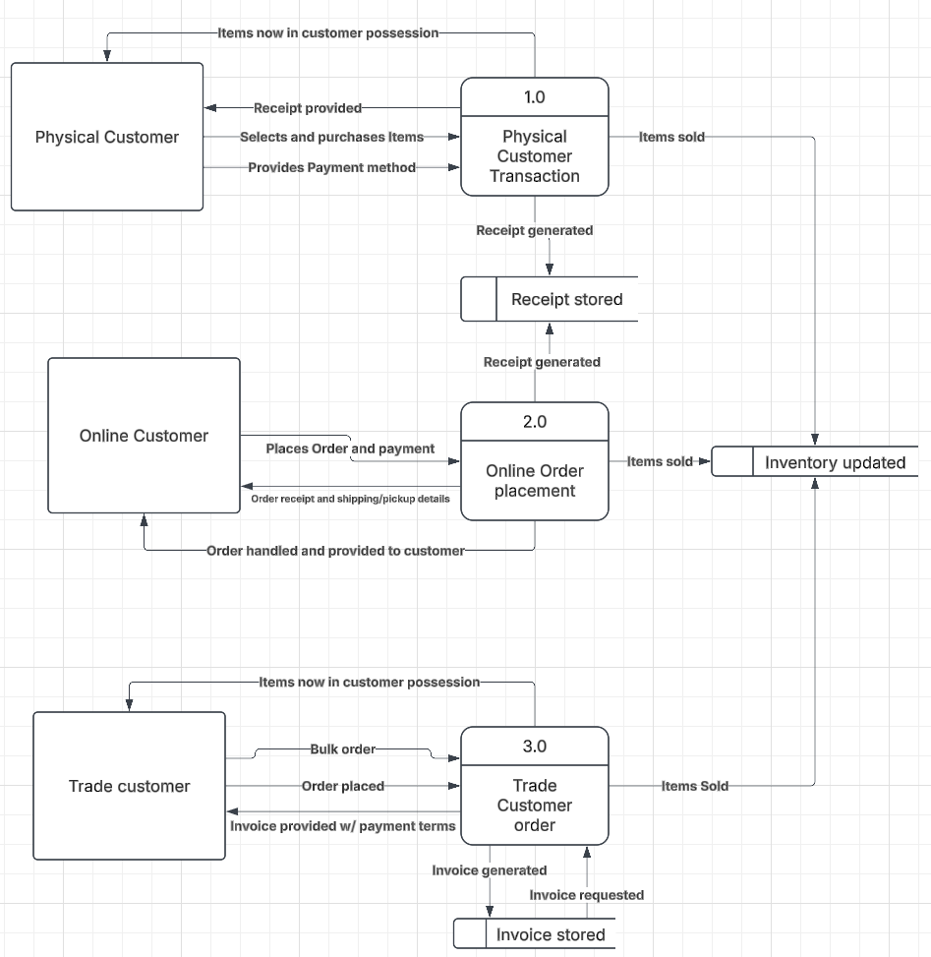

Lower-level Diagrams (Level 1)
Process 1
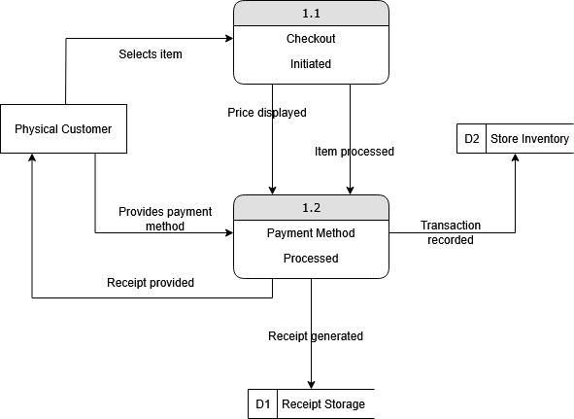
Process 2
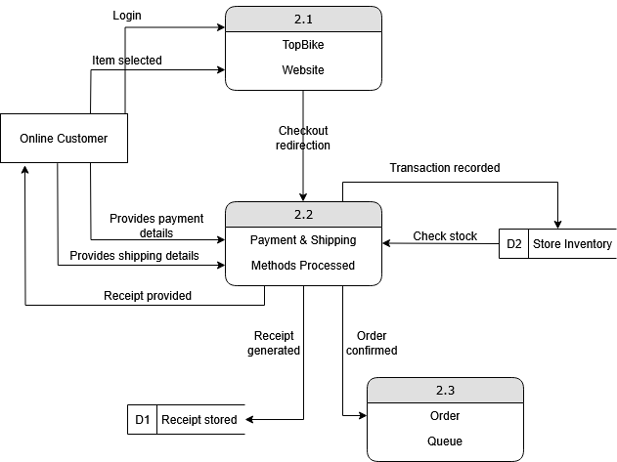
Process 3
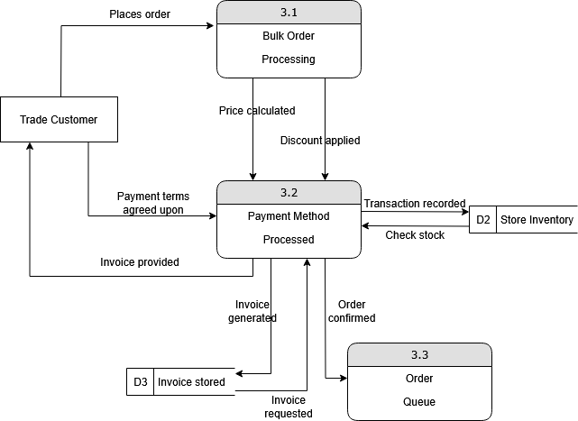

Part 3 - Data Models

Entity-Relationship Diagram

Diagram

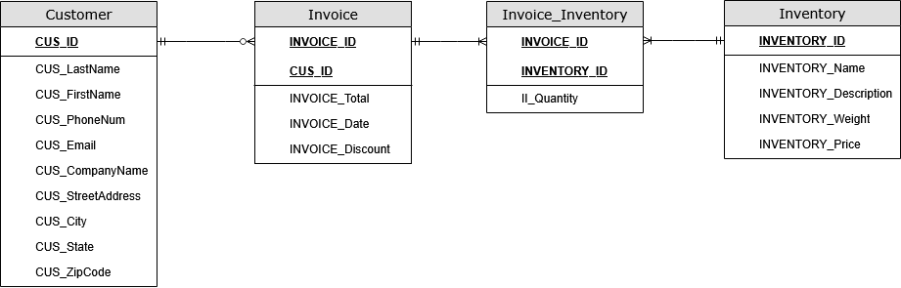

Overview
Our level 0 data-flow diagram previously consisted of the external entities trade customer, physical customer and online customer. Here, we have simplified these into a single entity called “Customer”, because those entities in the DFD shared similar functions. Similarly, the “Invoice” entity condenses the data stores “Receipt stored” and “Invoice stored”.
In the second part of this project, we defined our system requirements which included bulk order processing and receipt distribution. To implement bulk order requests and processing, we have included an order quantity attribute in the “Invoice_Inventory” table, which will identify bulk orders at a certain threshold. The “INVOICE_Discount” attribute in the “Invoice” entity then applies a percentage-based discount if that threshold is passed.
Additionally, the Invoice entity in this ERD functions as both a receipt and invoice system, where it will tie order information such as “INVOICE_ID” and “INVOICE_Date” to the “Customer” entity, allowing us to track orders easily.
A final point of interest is the “Invoice_Inventory” table, which is a junction table created to bypass the many-to-many relationship between the “Invoice” table and the “Inventory” table.

Model Breakdown

Entities and Attributes
Customer
- PK: CUS_ID (Primary Key)
- Other attributes: CUS_LastName, CUS_FirstName, CUS_PhoneNum, CUS_Email, CUS_CompanyName, CUS_StreetAddress, CUS_City, CUS_State, CUS_ZipCode
Invoice
- PK: INVOICE_ID (Primary Key)
- FK: CUS_ID (Foreign Key from Customer)
- Other attributes: INVOICE_Total, INVOICE_Date, INVOICE_Discount
Invoice_Inventory (Associative/Bridge Entity)
- FK1: INVOICE_ID (Foreign Key from Invoice)
- FK2: INVENTORY_ID (Foreign Key from Inventory)
- Other attributes: II_Quantity (Quantity of items in the order)
Inventory
- PK: INVENTORY_ID (Primary Key)
- Other attributes: INVENTORY_Name, INVENTORY_Description, INVENTORY_Weight, INVENTORY_Price

Relationships
Customer - Invoice
- One-to-Many (1:M)
- A customer can have zero or more invoices.
- An invoice is generated for exactly one customer.
Invoice - Invoice_Inventory
- One-to-Many (1:M)
- An invoice can include multiple inventoried items.
- Each invoiced item belongs to one invoice.
Inventory - Invoice_Inventory
- One-to-Many (1:M)
- An inventory item can be included in multiple invoices.
NOTE: Each invoice_inventory references one inventory item.
Data Validation

Primary and Foreign Key Validation
Our team has ensured that the integrity of the database design is upheld through primary and foreign key validation. Specifically, the foreign keys “INVOICE_ID” and “INVENTORY_ID” in the “Invoice_Inventory” table are correctly structured to reference the primary keys in their respective parent tables, ensuring referential integrity. This guarantees that every entry in the “Invoice_Inventory” table corresponds to valid records in both the “Invoice” and “Inventory” tables, preventing orphaned records and maintaining data consistency.
Furthermore, to preserve the uniqueness of each order-item relationship, a composite key (INVOICE_ID + INVENTORY_ID) has been implemented within the “Invoice_Inventory” table. This acts as a safeguard against duplicate entries, ensuring that no order contains the same item more than once in a redundant manner and enhances the reliability of the database.

Normalization
The database schema has also been normalized to the Third Normal Form (3NF), ensuring a well-structured and efficient data model. In accordance with 3NF, all non-key attributes are fully functionally dependent on the primary key, eliminating any partial dependencies that could lead to redundancy or inconsistencies.
Each entity is clearly defined with appropriately assigned attributes, reducing the risk of anomalies during data modification operations such as inserts, updates, or deletions. This will also ensure the resulting database is capable of efficiently handling complex queries.

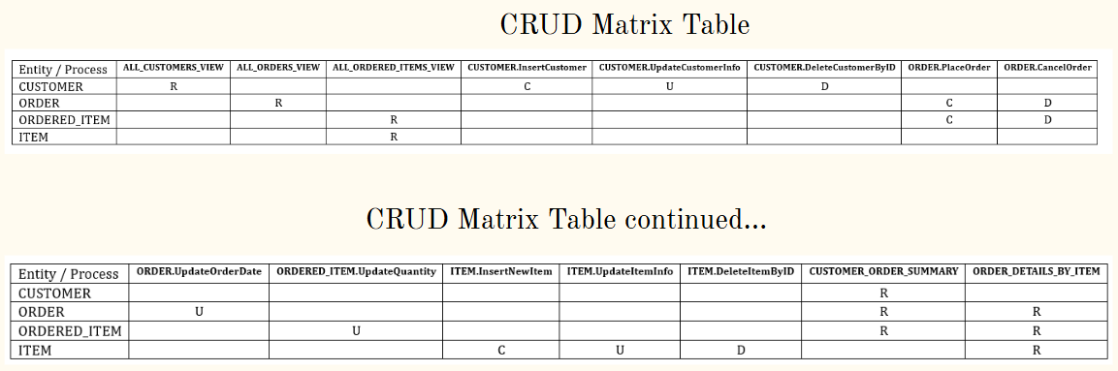
CRUD Matrix Table

Part 4 - User Interface Design

User Interface

User Profiles

Emma Rodriguez - Retail Customer
Age: 28 |  | Occupation: Fitness Instructor |  | Tech Comfort: High
Background: |  |  | Shops online frequently, health-conscious, values quality and speed
Goals: |  |  | - Easily browse and order bike accessories  - Track orders in real time
Pain points: |  |  | - Gets frustrated with confusing layouts or hidden shipping info
Behavior: |  |  | - Places small orders frequently  - Accesses the website on her phone
Expectations: |  |  | - Clean, mobile-friendly interface  - Fast checkout with multiple payment options

Jim Wallace - Trade Partner
Age: 45 |  | Occupation: Owner of “Jim’s Outdoor Sports” |  | Tech Comfort: Moderate
Background: |  |  | Places monthly bulk orders for resale
Goals: |  |  | - Order large quantities with applied discounts  - Receive accurate invoices and clear payment terms
Pain points: |  |  | - Manual paperwork and delayed invoicing slow down his business
Behavior: |  |  | - Orders via desktop  - Logs in once or twice a month
Expectations: |  |  | - Easy-to-navigate order forms  - Automated invoices and reliable status updates

Mia Patel - TopBike Store Clerk
Age: 22 |  | Occupation: Part-time clerk |  | Tech Comfort: Moderate
Background: |  |  | Handles point-of-sale and customer inquiries
Goals: |  |  | - Process sales quickly at checkout  - Update stock in real-time
Pain points: |  |  | - Hates when the POS crashes or when the interface is cluttered
Behavior: |  |  | - Uses touch screen POS daily
Expectations: |  |  | - Simple layout with clear product info  - Big buttons, fast response time

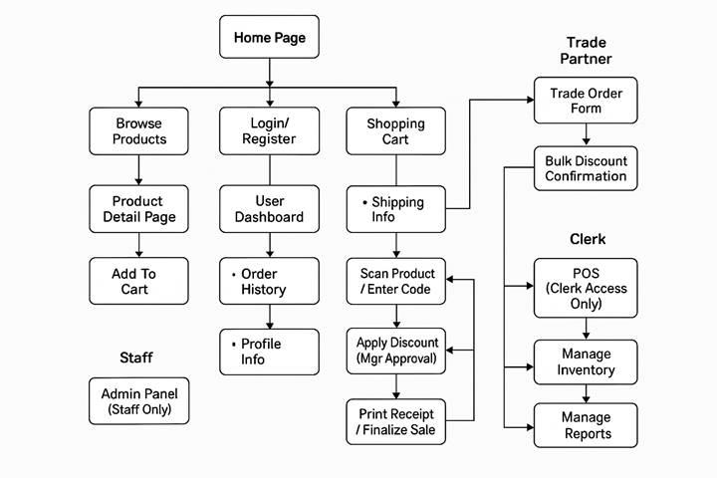
Interface Structure Diagram

UI Prototypes
Homepage (Wireframe)
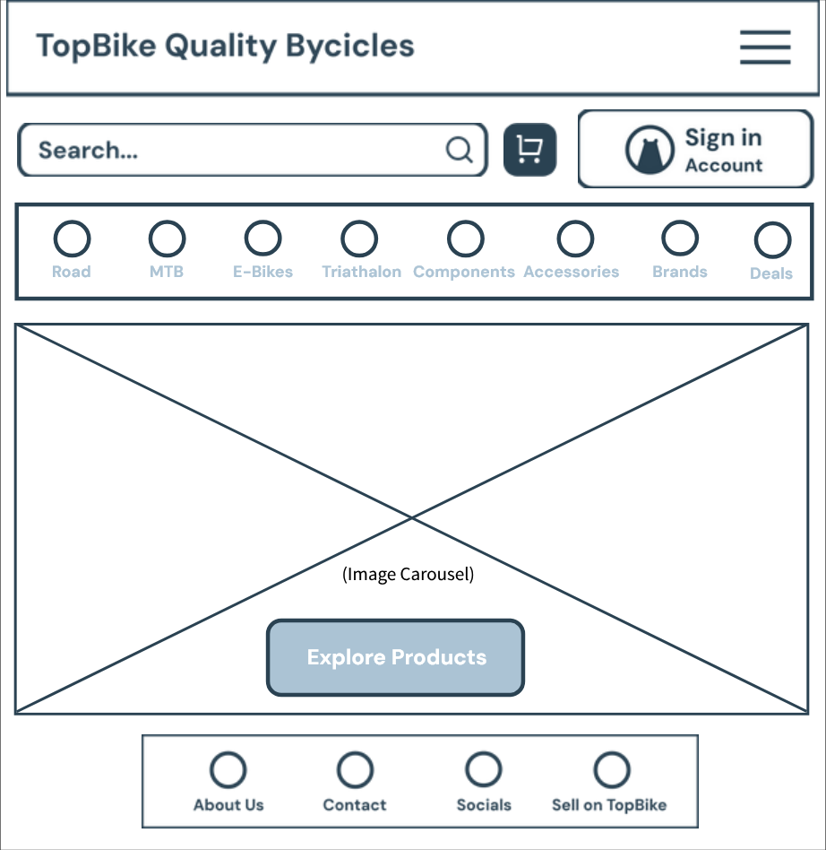
Inventory Management (Wireframe)
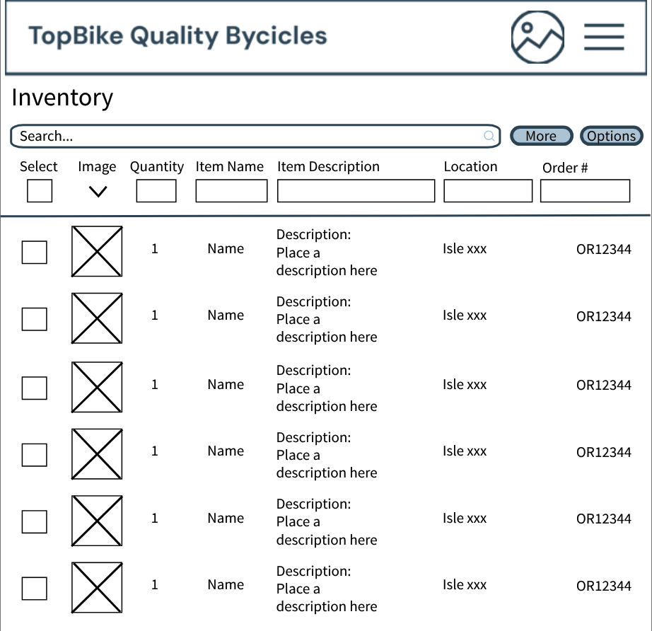
Log-in / Sign Up (Form)
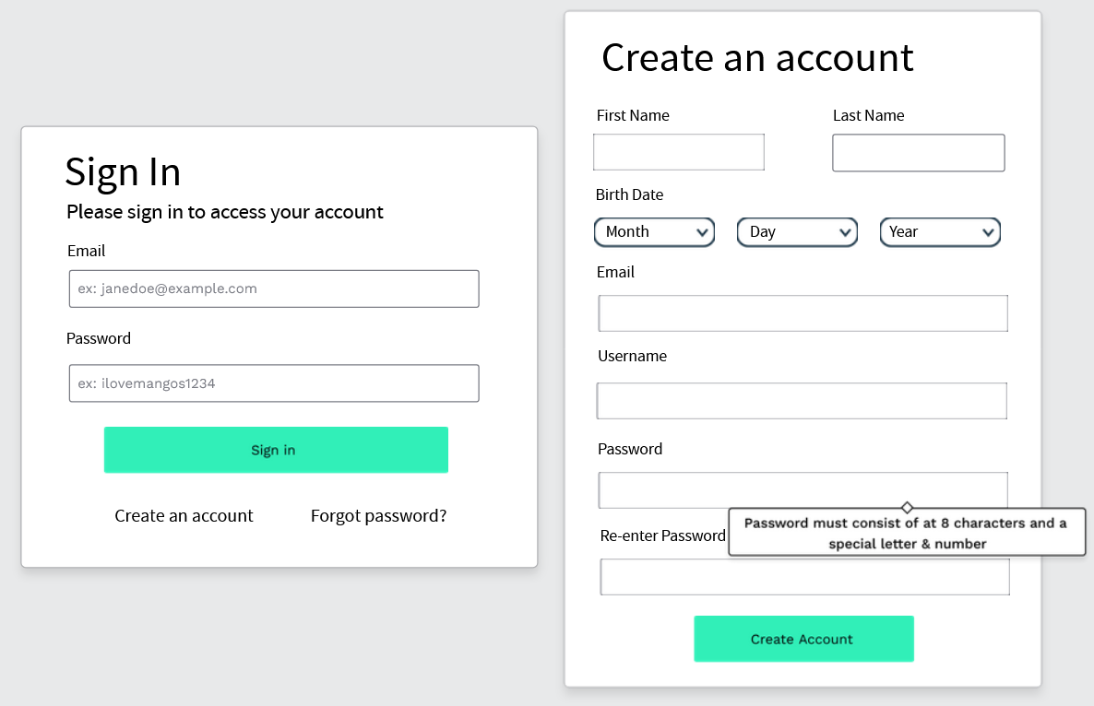
Checkout (Form)
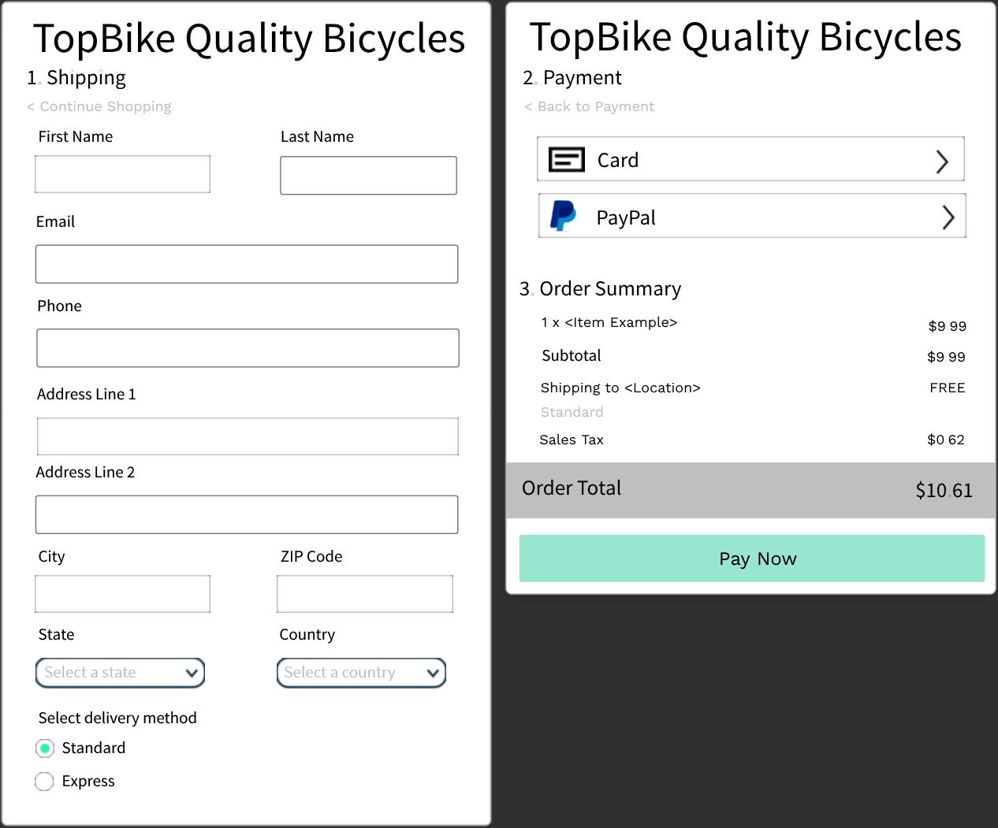

Order details (Report)
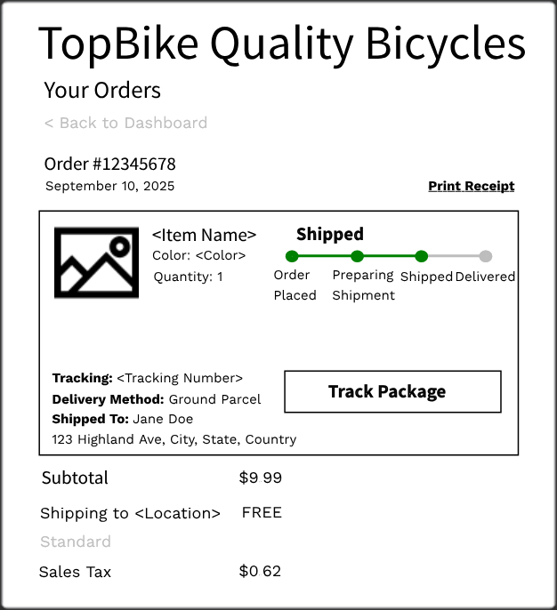

Physical Data Flow Diagrams
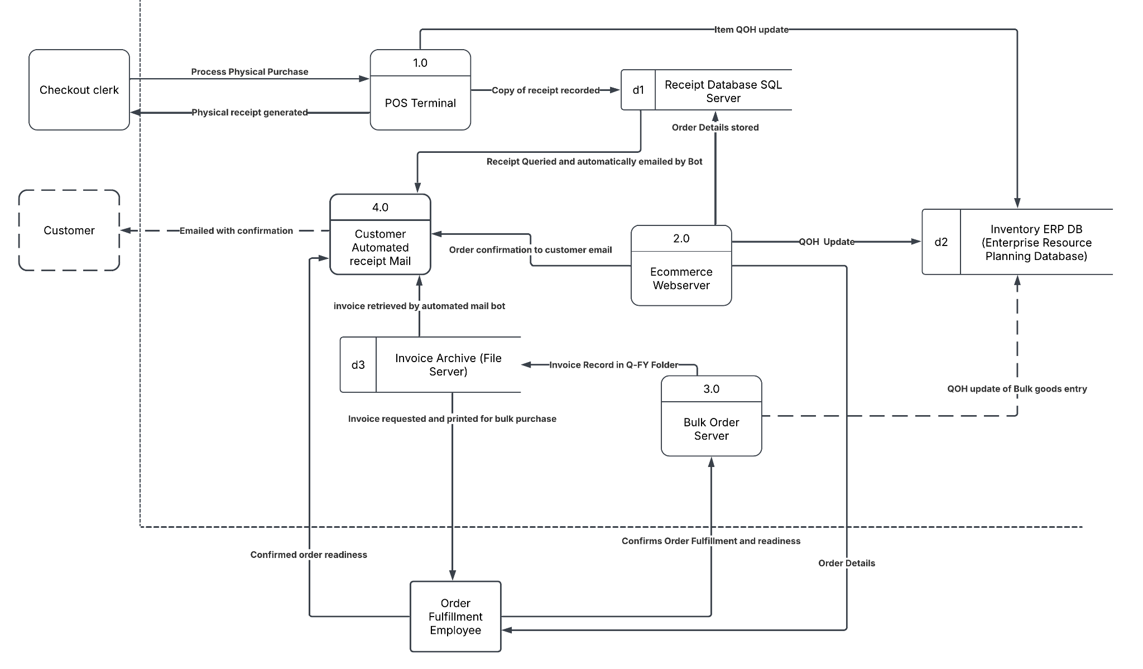

Structure Chart
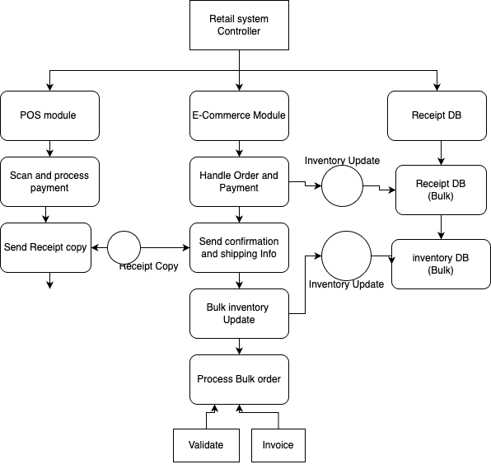

Part 5 - Test Plan

Physical ERD

Diagram
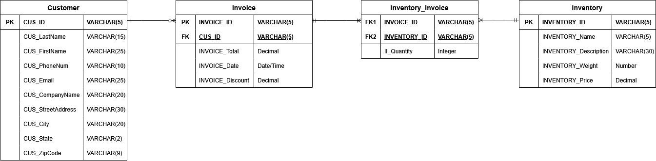

Overview
Not a lot has radically changed from the logical data model in part 3: the key points that have been changed are the inclusion of primary and foreign key identifiers in the model itself, as well as adding fields with their respective data types. Otherwise, the relationships, cardinality and core entities have remained the same.
Primary and foreign key data types were restricted to a length of 5 for simplicity and storage efficiency. Also of note: some of the data type fields have notably restricted lengths, such as the “CUS_State” and “CUS_ZipCode” fields—this is simply because state can be commonly represented in a 2-letter abbreviation, and ZIP codes never exceed 9 digits in length.

Test Plans

Point-of-Sale (POS) System
Test Plan: Point of Sale
Program ID: TopBike_PointofSale Version number: 1.0
Tester: __________________ Date designed: May 7, 2025 Date conducted: _______
Results: ☐ Passed ☐ Open items: ___________________________________
Test ID: POS-01
Requirement addressed: REQ-POS-001: Customers must be able to purchase products in-store using the POS terminal.
Objective: Verify end-to-end customer purchases via POS, including item scanning, payment handling, inventory updates, and receipt generation.
Test cases
Interface ID | Data Field | Value Entered
POS Terminal | Product Barcode | "1234567890123"
POS Terminal | Product ID | "INVALID123"
Payment Window | Payment Method | "Credit Card"
Payment Window | Cash Amount | "$20 on $14.99"
POS Terminal | Cancel Transaction | "Clicked"
System Restart | Recovery Mode | "Restart POS mid-transaction"

Script
- Launch POS terminal application.
- Scan a valid product barcode (1234567890123).
- Manually enter an invalid product ID (INVALID123).
- Select credit card as payment method and complete transaction.
- Run another transaction, this time with $20 cash for a $14.99 purchase.
- Attempt to cancel a transaction before finalizing payment.
- Simulate a system crash/restart and observe if the session clears and logs the event.

Expected results/notes
- Step 2: Product appears with correct name and price in cart.
- Step 3: Error message displayed; product not added.
- Step 4: Credit card payment completes and receipt is printed.
- Step 5: Correct change returned; receipt includes item and amount paid.
- Step 6: Cart is cleared and transaction aborted successfully.
- Step 7: Crash is logged; upon restart, previous session is not resumed.

Online Ordering System
Test Plan: Online Ordering
Program ID: TopBike_OnlineOrdering Version number: 1.0
Tester: ______________ Date designed: May 7, 2025 Date conducted: ____________
Results: ☐ Passed ☐ Open items: ___________________________________
Test ID: ORD-01
Requirement addressed: REQ-ONL-001: Customers must be able to place orders via the website.
Objective: Verify end-to-end online ordering, from product search through payment processing and order confirmation.
Test cases
Interface ID | Data Field | Value Entered
Home Page | Search Field | “Mountain Bike Pro”
Product Details Page | Quantity Selector | “2”
Cart Page | Coupon Code | “SPRINGSALE2025”
Checkout Page | Shipping Address | “456 Elm St, Anytown, USA”
Payment Page | Credit card number | “4111 1111 1111 1111”
Confirmation Page | Email Address | “John.Smith@example.com”

Script
- Navigate to https://topbike.example.com.
- (If required) Log in using valid credentials.
- On the Home Page, enter “Mountain Bike Pro” in the search bar and submit.
- From the search results, click the desired product to open the Product Details Page.
- Set quantity to 2 and click Add to Cart.
- On the Cart Page, enter coupon code SPRINGSALE2025 and click Apply.
- Click Proceed to Checkout and enter “456 Elm St, Anytown, USA” as the shipping address.
- Then, continue to the Payment Page, and enter credit card number 4111 1111 1111 1111, valid expiration date, CVV, and billing address.
- Submit payment and wait for the Confirmation Page.
- Verify that the order number appears and that a confirmation email is sent to John.Smith@example.com.

Expected results/notes
- Step 3: “Mountain Bike Pro” appears in search results with correct pricing and availability.
- Step 5: Cart updates to show two units of the selected product, correct line-item price.
- Step 6: Order total reflects the SPRINGSALE2025 discount.
- Step 7: The Shipping address is saved and displayed on the review page.
- Step 8: Payment processes without error; transaction is recorded.
- Step 9: Confirmation Page displays a valid order number, order summary, and estimated delivery date.
- Step 10: Confirmation email arrives within 5 minutes, contains order details and contact info.

Invoice Generation System for Trade Customers
Test Plan: Invoice Generation
Program ID: Topbike_InvoiceGeneration Version number: 1.0
Test: ______________________ Date designed: May 8, 2025 Date conducted: ______
Results: ☐ Passed ☐ Open items: ___________________________________
Test ID: INV-01
Requirement addressed: REQ-INV-01: Invoices should be generated for trade customers only.
Objective: Generate accurate, itemized invoices for trade customers based on purchase orders, including calculations for discounts, taxes, and totals, and export as a PDF. Handle invalid inputs and maintain proper records.
Test cases
Interface ID | Data Field | Value Entered
Invoice Generation Page | Purchase Order ID | "PO12345"
Invoice Generation Page | Trade Customer ID | "T001"
Invoice Details Page | Tax Rate | "7.5%"
Invoice Details Page | Discount Code | "TRADE2025"
Payment Page | Payment Method | "Credit Card"
Payment Page | Card Number | "4111 1111 1111 1111"
Confirmation Page | Export Option | "Generate PDF"
Error Handling Page | Invalid PO ID | "INVALID123"

Script
- Access the Invoice Generation module.
- Enter a valid/invalid Purchase Order ID and observe the response.
- Apply trade customer discount if eligible.
- Calculate tax and verify totals.
- Attempt to generate and export an invoice as a PDF.
- Simulate a system crash during generation and observe the system response.

Expected results/notes
- Step 1: Valid PO = An invoice is generated with accurate itemization, totals, and discounts.
- Step 2: Invalid PO = Error message displayed.
- Step 3: Discount applied correctly for eligible trade customers.
- Step 4: PDF generated with correct formatting and content.
- Step 5: The system recovers from the crash without incomplete records

